
Trustworthy Humanities
The NST Geography & History Networks
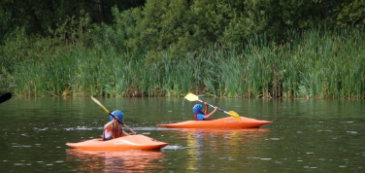
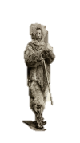

Who are the networks for?
For all geography and history leaders in NST schools interested in becoming highly skilled specialists in their subject.
What will we do?
- Develop a group of practitioners with specialist subject knowledge and skills for geography and history teaching
- Provide purposeful leadership development specific to improving geography and history teaching all year groups
- Learn about effective pedagogy, curriculum design, resources and assessment ideas and how to implement these effectively in your school
- Provide local, national and international updates about each subject
When and where?
Monday 25th February 2019, 4:00 – 5:30pm at Forest Fields Primary and Nursery School
(Latitude 52.97038, Longitude -1.166278)
Why should I come?
The intention is that the network will respond to needs identified by you, and become the main driver of school improvement and support within the trust to create great teaching and learning for history and geography in every NST school.
Despite the diversity of our schools, we share common challenges and this forum will be a great place to unpick some those tricky problems, consider research evidence and trial solutions.
The networks will be led by a wider group of experienced geography and history specialists who will share expertise in all aspects of the subjects.
There will also be cake.
If you have ideas about what should be on the agenda for future meetings or how the network could operate most effectively, please give Beth or myself a call or an email.
Looking forward to meeting everyone,
gareth.denman@forestfields.nottingham.sch.uk
beth.fowkes@forestfields.nottingham.sch.uk
0115 9156872
Inaugural History and Geography Network Meeting
Forest Fields Primary and Nursery School
Monday 25th February 2019
4:00 – 5:30pm

Agenda

- Introduction and aims of the group – register details of attendees

- Subject updates from national bodies

- Speaker Matthew Dix: Teaching history as part of a knowledge rich curriculum

- Discussion about the group:

- What do we want the group to do?
- What do we want to cover next time?
- Do we want a separate History and Geography Networks?

- Networking time and departure

