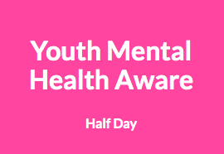
Youth MHFA Awareness Half Day online course
Tuesday 15th September or Monday 5th October 9.30am-12.30pm
This introductory three hour session raises awareness of young people’s mental health. It covers:
- Some of the common mental health issues affecting young people, such as depression and anxiety
- Skills to work more effectively with young people living with mental health issues
- Ways to support young people with a mental health issue and relate to their experiences
Everyone who completes the session receives:
- A certificate to say they are Youth Mental Health Aware
- A manual to keep and refer to whenever they need it
Course outcomes
By the end of the course, participants will be Mental Health Aware and will be able to:
  - Define mental health and emotional wellbeing
  - Relate to young people’s experiences
  - Recognise some signs of mental health distress
  - Start a supportive conversation about mental ill health
  - Practise self-care
Cost
£13 per participant to cover the cost of the course manual

“I learned to show more empathy, to have more confidence in asking questions and talking about mental health.”
-----------------------------------------------------------------------------------------------------------------------------
To Apply
Complete the following and return to: karen.smith2@nottinghamcity.gov.uk

Name:

School:

Please indicate prefered date: September Tuesday 15th October Monday 5th

Role:

E.mail address:

Postal address for manual:

Contact e.mail for invoice:

“I learned to show more empathy, to have more confidence in asking questions and talking about mental health.”

