How do we read? JThompson©Copyright 2020
Say the sounds

Spot the sounds? s a t p i n

I liked the part_____ because....

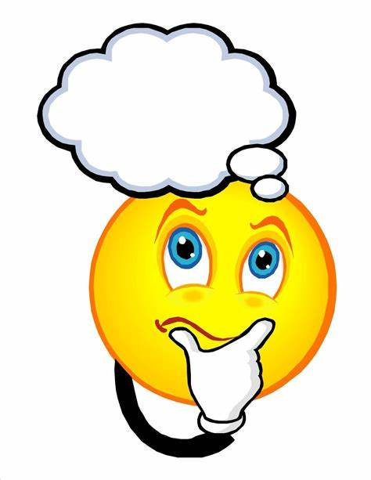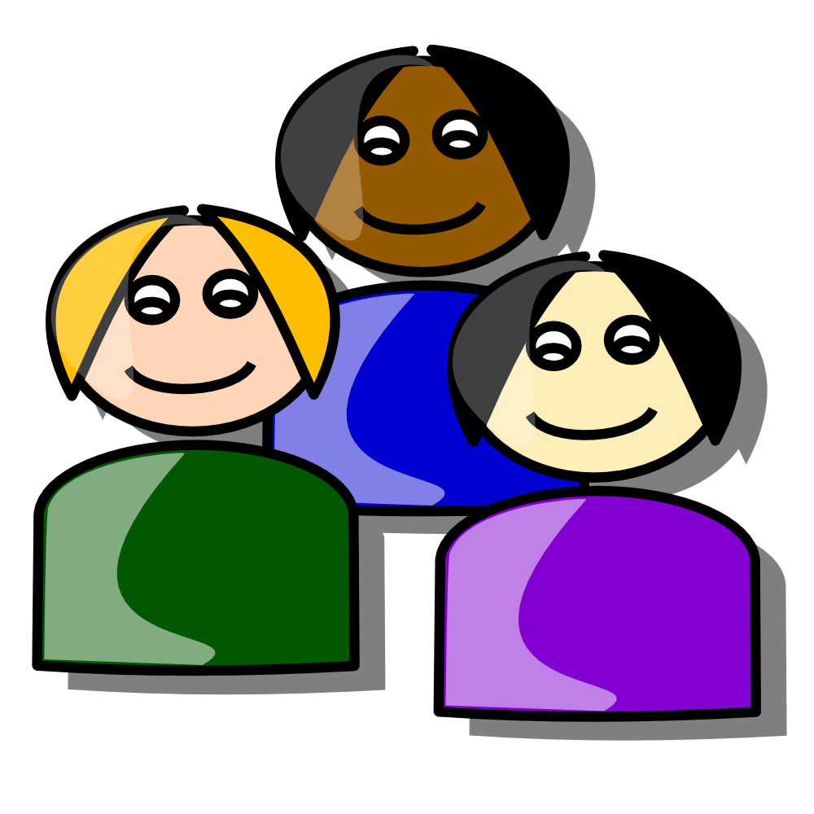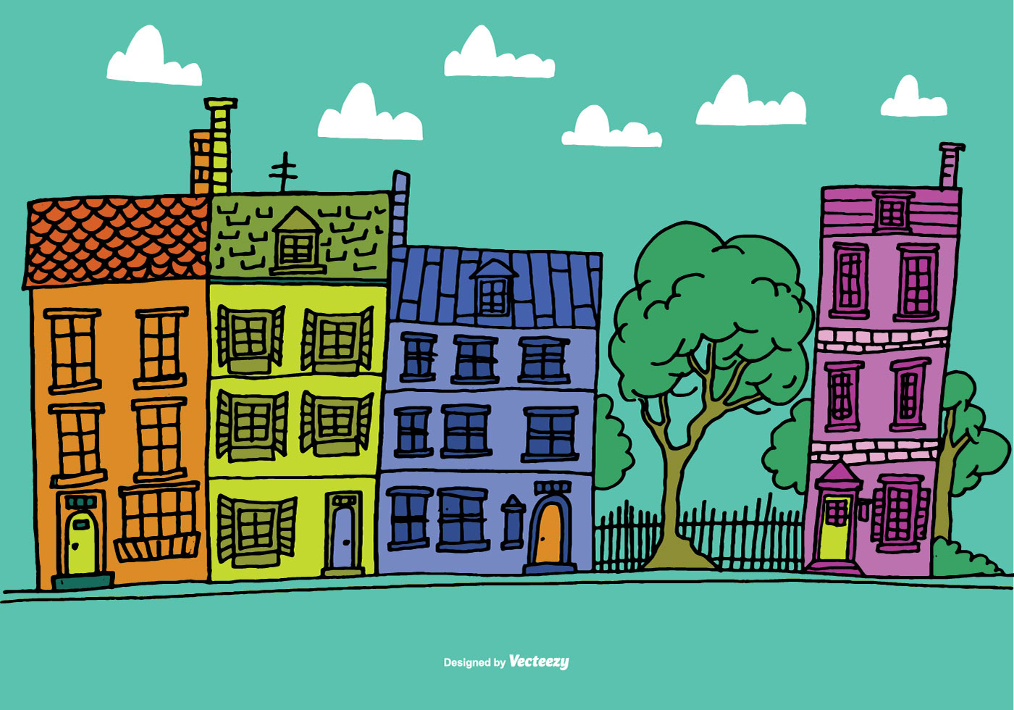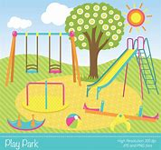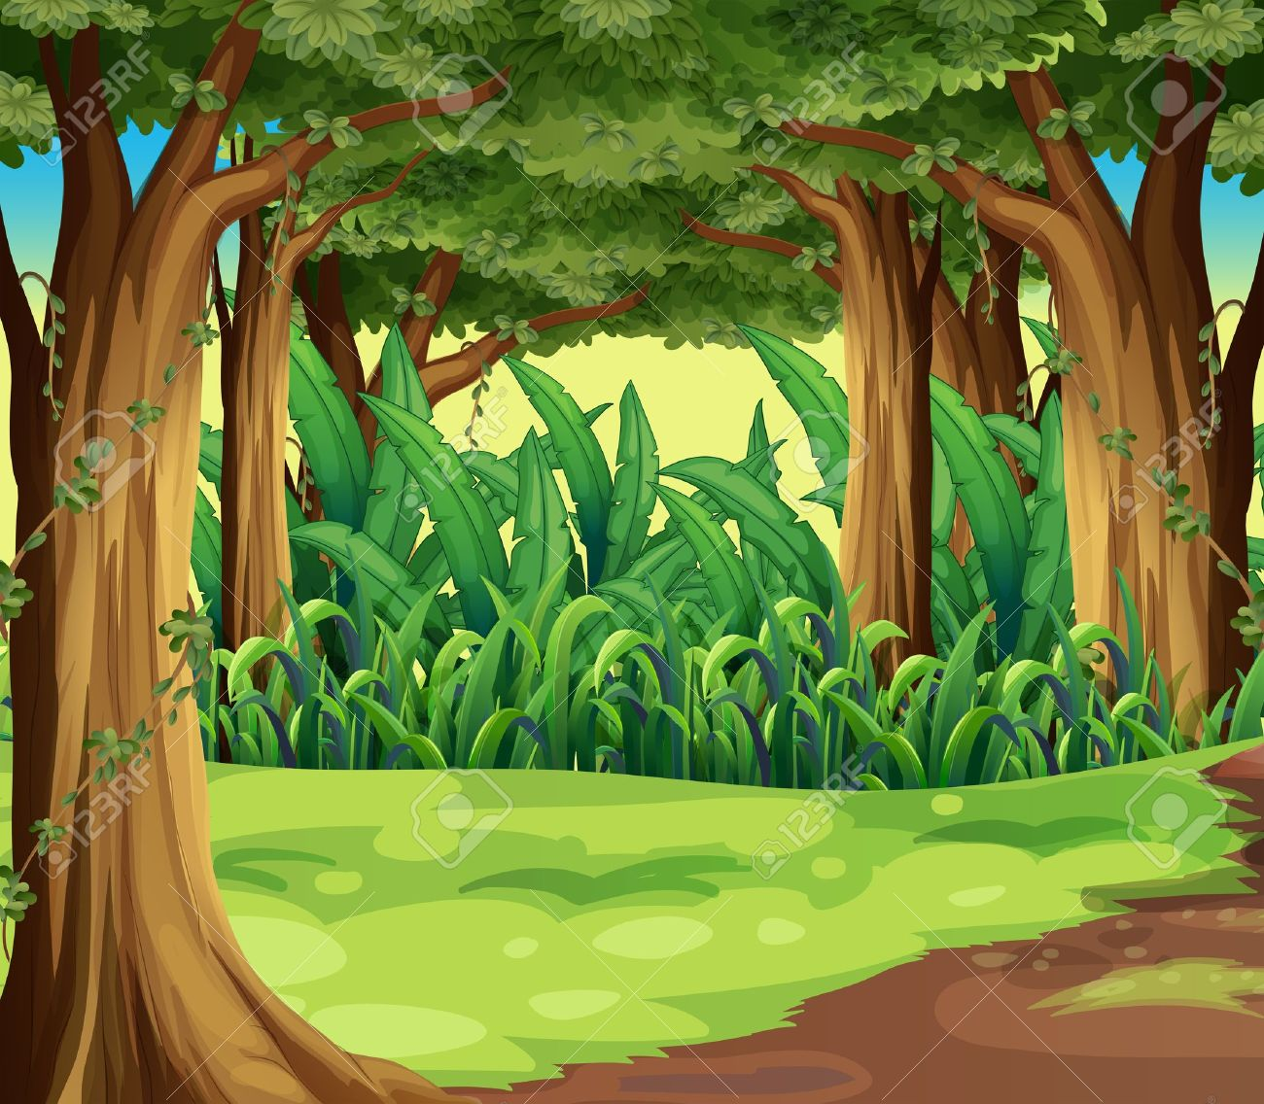
What? How? Who? Where ? When?
Why?
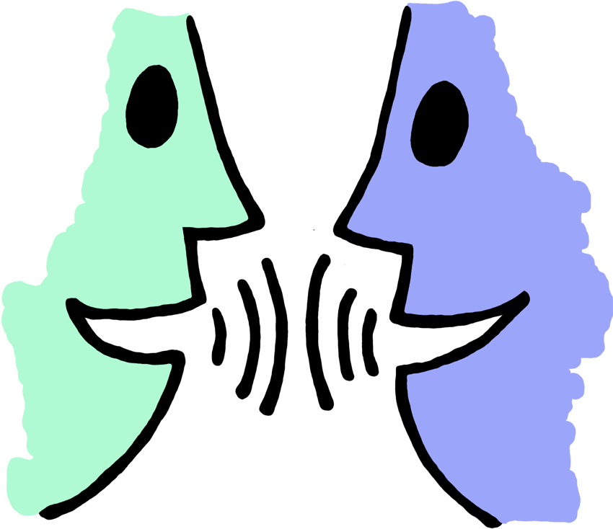Talk about it

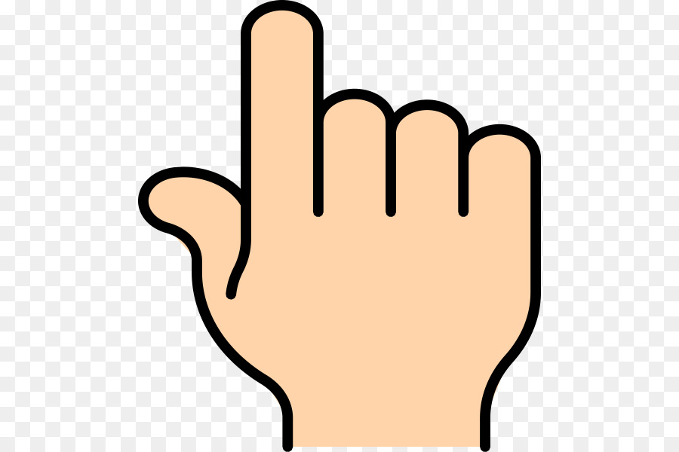Pointy finger
. . . Full stops
JThompson Copyright©

JThompson Copyright©2015

How do we read words? JT©

Blend the sounds

Single sounds Digraphs
s t m shop ai ee

I liked the part_____ because....

What? How? Who? Where ? When?
Why?

? ! … Full stops

‘‘Speech marks’’

Re-run Wow words!
.

How do we read texts? JThompson©Copyright2015

Purpose ? Audience?

Chunk it!
syllables
Words and spelling patterns
Words within words chim pan zee

IllustrationsOrganisation

? ! , :; Punctuation

‘‘inverted commas ’’

Re-run
JThompson©Copyright2015

