Remote Learning Decodable Reading

In addition to online remote lessons from RWinc and Letters and Sounds
Letters and Sounds: Home - Letters and Sounds
Read Write Inc: https://www.youtube.com/watch?v=H9rGoXkmeyU

We have discovered these decodable e –books for home.
Collins Big Cat Ebook Library
https://www.risingstars-uk.com/subjects/reading-and-ebooks/rising-stars-reading-planet/reading-planet-reception-and-ks1/rocket
Free eBook library – practise reading with phonics eBooks | Oxford Owl
Bug Club Family (pearson.com)

Story time
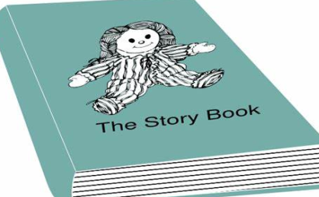
We have also discovered some excellent websites where stories are read to children -

Book Trust
https://www.booktrust.org.uk/books-and-reading/have-some-fun/
Jackanory Junior
https://www.bbc.co.uk/programmes/b007t9wg
Storytime online
https://www.storylineonline.net/

