Smart Kids Phonics Resource Review
By Janet Thompson Phonics Consultant
What am I looking for when choosing resources?
- Aligned to letters and Sounds?
- Word complexity (boat----- boatman)?
- Element of repetition for less able: i.e boat, coat, goat.
- Suitability for whole class and group? Size, font, colour
- Words with and without sound buttons?
- Storage and organisation?
- Value for money?
- How will this meet the needs of ALL my children?
- Words are relevant, promote vocabulary opportunities?

Class Freizes Phase 2,3 and 5 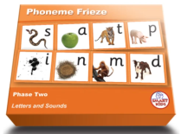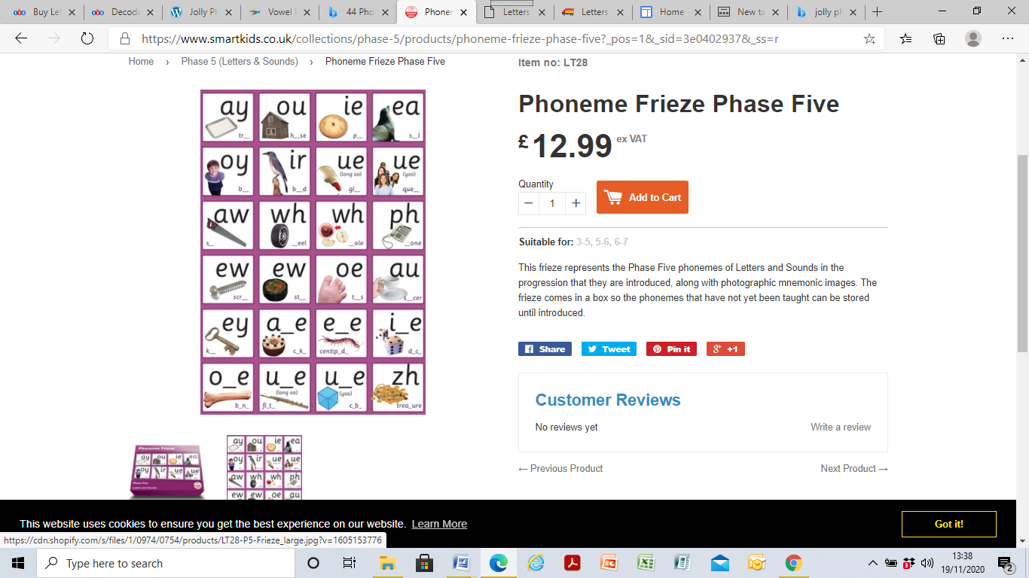

These are brilliant! Completely and accurately aligned to Letters and Sounds order so can display as you teach. Superb size which make them visible enough for a class wall but not too large. Wall space can be a big issue in classrooms.
The images are photographs so this is highly appealing to children, they are relevant and within their world of understanding. The images are well chosen as they are crisp and clear in their speech articulation. Most images are an excellent prompt as in j’j for Jam. Some phonemes and images could lend themselves to rhyme and alliteration. Some actions could be used for some phonemes which would help engagement and retention also.
Phase 3 included the voiced and unvoice ‘th’ in a simple but clear way.

Phase 2 images are not linked to the letter formation. Linking both for this phase is a powerful tool. The light image for ‘igh’ in phase 3 isn’t the best or clearest image. Being picky now!
Personally I like jjjj... jelly as we like to wobble our bellies like jelly and relates to parties, etc.
Phase 3 and 5 images are equally superb. Included ue- you and ue- oo which is useful.

The different colours for each phase are helpful, although phase 3 and 5 are very similar colours.
Phase 5 ‘oy’ boy and ‘ir’ girl would be good. My girls didn’t like being left out! So a boy and a girl for equality and all that! Not sure about the wh- whole? Ph- might need to be a mobile phone?
A small table top size version to match will greatly aid children’s writing and help consistency.

Summary: Overall good value for money at £12.99. Well boxed, colour for each phase, good size images, font type and would greatly aid the recall, retention and understanding of a new phoneme. Using simple actions and rhymes will further promote the success in children’s learning. A most useful resource.
Phoneme Frieze Phase Two – Smart Kids

Flash cards: Phase 3 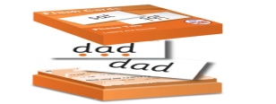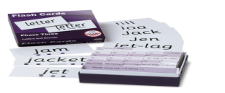
Criteria | Positive aspects | Comments
- Aligned to letters and Sounds?  - Word complexity (boat----- boatman)?  - Element of repetition for less able: i.e boat, coat, goat.  - Suitability for whole class and group? Size, font, colour  - * * and non sound buttons?  - Storage and organisation?  - Value for money?  - How will this meet the needs of ALL my children?  - Words are relevant, promote vocabulary opportunities? | ✓  Some  Some  x  ✓  ✓  ✓  ✓  ✓  ✓ | More challenging words needed?  There are combination words (with phase 2 and 3 phonemes included) and blank cards so teachers can write more challenging words.  Repetition: ensuring there are 2,3 with similar phonemes to reduce cognitive overload and enable fluency of skill for less able.  Coat, boat, goat ( the mixture of road, toad, et....)  Buy directly from Smart kids at only £22.99.Good value for money.

These are my favourite flashcards for teaching not only because they are tightly aligned to letters and sounds but the best feature is that they are double sided with one side showing sound buttons and the other no sound buttons. This enables the teacher to scaffold the blending process to support the less able with the sound buttons and then enable further learning by progressing to blending to read words with no sound buttons.
They are robust, have a glossy sheen, well sized and the list of words in the front of each sections allows a quick ‘on the go’ glance of content. So you can quickly check the content, suitability for all abilities in your class.
Good value for money because they come ready to ‘teach.’ There is no laminating or sorting, re-organising, cutting up , etc! Storage is small, compact and organized.
The combination words at the back of the box, aimed to give challenge and consolidate which is a bonus.
There are tricky words and high frequency words included, but personally I would prefer these to be different in some way, i.e red as in stop! Think! These are tricky?
Spare blank cards are also provided which allow teachers to write a few of their own words, perhaps to fit in with a theme, link to your literacy or simple more challenging words for the higher ability. This is really useful as time is short in a busy classroom!

While most words do have a sense of word complexity, I would prefer there to be more challenging words as often Letters and Sounds is taught whole class with some children who really need more challenging words to develop their blending skills.
There are also children in who are confidently blending phase 3 digraphs so would be very capable of blending using phase 4 aspects, i.e teaching ‘ee’ progressing to sheep creep, igh- flight, bright ,etc may be a way to stretch and challenge the more able?
Phase 4 is about blending accuracy so makes perfect sense for high achieving blenders as we never want to cap the learning. The range of words are relevant, child friendly, promote talk and saying a sentence with some good vocabulary opportunities.

Then to support the less able with not only simple words, they also need repetition to practise blending, build fluency and develop their autographic memory. For example: coat, boat, goat....... soap, toad, road, cloak, float....boatman.
Phase 3 ‘ure’- has ‘sure’ and ‘assure’ which make the ‘sh’ sound so these are not phonetic. However most publishers make this error. It is a difficult one!

To summarize, overall good value, good quality and flexible in their use for group or whole class. A methodical list linked to L&S. Storage and organisation make is quick and easy to access. Spare cards allow to write more challenging words too.
Letters and Sounds Flash Cards Phase Two – Smart Kids

Janet Thompson
Phonics Consultant

