Phonics Lesson Structure Phase 5 Part 2 Same spelling but different sound.Time: 20-30 mins (approx) Frequency: Daily JThompson April 21 Long and short vowels EA

Revise and Review  Good sounding out! |  | Teach  TP- We are learning the X sound and .. | Practise | Apply  TP-We can sound out x words/ read, write...
Recap & Recall sounds  1-2 minutes | Rapid Read  3 minutes max | Same sound, different spelling example  *Model x2 then chn do.  5 minutes  Introducing ea Short .........long or short? (already know long ea) | Word level, reading into spelling- sentence work  Today: We are learning to read words with the Same spelling but different sound. TIP: Sing long/short vowels.  1.We know ‘ea’..eat the peach.... MTYT. (show images + words)*note the long vowel phoneme. TIP: Stretch arms  Read words: eat read stream beach peach * long vowel phonemes.  2. *The grapheme ‘ea’ (ee)... can sometimes say a short sound.... e (phase2) ...spread on the bread (show image, do action). ea – ‘same spelling BUT different sound.’  Can be ... ‘EA‘ /ee /(MTYT) and ‘EA’ /E/ (MTYT)eat eat the peach spread on the bread  long vowel short vowel phoneme  *Read  ea- head ea- b r ea d s p r ea d  ACTIVITY: Help! Read and sort – long or short?  leaf bread  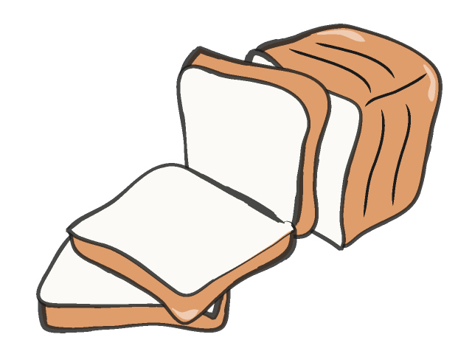  Apply: read sentence spot ‘ea’- long or short vowel’  10 minutes  5 minutes
Recap previous phonemes (x10)  What is a phoneme? Yes, a...  What is a di/ trigraph? Yes... What is a grapheme? Yes how we write a sound.  (*grapheme- higher level- optional)  1. (Our turn) ‘Together..  2 . Super fast/random  (Your turn) ’Your turn...’  *oa,oe,o-e (*cow)  End of week......  Recall graphemes ( w/b’s)  ‘Let’s use graphemes to write the sounds.’  1.MTYT- ‘x, x’....  2.Model write y.... chn use magic finger (hide it).  3.Say- ‘x’- Gesture- write it. Chn to say sound (STS) as they write y.  4. ’1,2,3 show me.’  5. Reveal grapheme on w/b- ‘Let’s check !’  Make teaching points  *Assessment opportunity - NO modelling. | Using a few words (from previous week ) blend to read words. Pause to (occasionally) put into a sentence verbally & chn to repeat. (MTYT)  Collaborative:  Blend to read words  (extend to aspects of 5. Focus Rapid Read as apt)  X1,2 new tricky words per wk Sound talk it. Say sentence MTYT.  Find easy bit  Find tricky part.  Read and say.  Quick fire with other tricky words. | 3. Hide and find it: Sing it back ‘ea.../e short/.’ Can be ‘ea-long (ee)’ into the pack of past 10 or so sounds. Quick say the sounds. (repeat until fluent- mixed/fast as apt). Point to our sound when you see it!* Can be x can be y . ‘OW ‘ grapheme- Can be ow (ou ow) can be ow (oa oe o-e.)  4.Write it : ‘we write ‘ea’ (short) digraph like this....’– in the air, on carpet, magic fingers, on w/bs x2,3 times (MTYT). Model + chn practise. STS as they write.  Optional- *we use graphemes to WRITE ‘OW’ digraph- higher level terminology.  5. Focus Rapid Read- x 4,5 focus sound words.  1.‘Digraph? Ea ( use long and short) *TIP this says ea (long)  This says ea (short) then blend.  3.RTW- show.  *Model x2  1.Chn do. 2.‘mix it up/super fast.’  3.Goal: chn RTW aloud (blend in head)  Outcome: We can know OW grapheme can say /ee/long and /ea/short.  Same spelling BUT different sound long or short vowel phonemes. | Time to segment and blend words with the new phoneme.  See letters & sounds for full details....  Word read + add sound buttons  or  Grapheme frame (R)  or  Word sort/ best bet (R/W)  or  Sound buttons (W)  or  Sentence work + tricky word/ dictation  (W) | Read a sentence  What’s our digraph? Can you spot any other di/trigraphs? Spot our tricky word?  ‘Yes this word has the digraph......’  Sentence dictation  or  Recall- sounds/words + tricky, quick write  or  Game- yes/no  Can children show what they know? ‘What did we learn today?’ Tell your partner ‘We can – read/write the x sound.’  or  REVISE KEY LEARNING  Focus Rapid read a few focus words (from input)_  Step 5- ( teach section)

