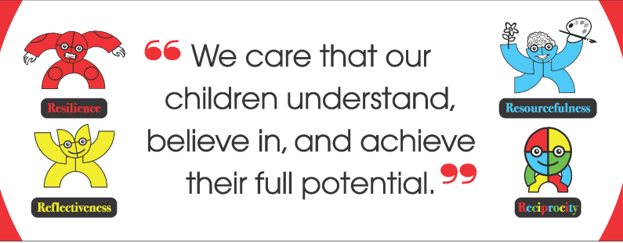 ***Allenton Community Primary School***

***Subject Leader Folder***

|  |  |
| --- | --- |
| 1 | **Intent**   * School intent * Subject Intent |
| 2 | **Implementation**   * **Knowledge is power** * Progression of skills/curriculum coverage * Links to other subjects * Enterprise opportunities * Consistent quality of teaching in my subject * **Amazing Allenton** * 4 Rs in my subject * Inclusion and support * Citizenship * **Enrichment** * Wider experiences * Career experiences/Aspirations * Our place in the world * **Keeping safe** * Safeguarding links * School Safety * Physical Wellbeing * Mental Wellbeing |
| 3 | **Impact**   * Evidence of work (including displays) * Case Studies * Stakeholder voice * Progress and tracking * Statutory Data (if applicable) |